Experiment 9

**Implementing Simple JSP**

Name: Sai Harsha Vardhan AVN

Roll-no: BCSE1823

Batch: ‘A’

**Aim**: Implementing Simple JSP

**Theory:**

Servlets are Java classes which service HTTP requests and implement the **javax.servlet.Servlet** interface. Web application developers typically write servlets that extend javax.servlet.http.HttpServlet, an abstract class that implements the Servlet interface and is specially designed to handle HTTP requests.

Steps to create a servlet example

There are given 6 steps to create a **servlet example**. These steps are required for all the servers.

The servlet example can be created by three ways:

1. By implementing Servlet interface,
2. By inheriting GenericServlet class, (or)
3. By inheriting HttpServlet class

The mostly used approach is by extending HttpServlet because it provides http request specific method such as doGet(), doPost(), doHead() etc.

There are few server’s to run your application , you can use either of those for example we have **apache tomcat server, Glassfishserver etc**. The steps are as follows:

1. Create a directory structure
2. Create a Servlet
3. Compile the Servlet
4. Create a deployment descriptor
5. Start the server and deploy the project
6. Access the servlet

Directory/File Structure for Servlet Programs to run is shown below:

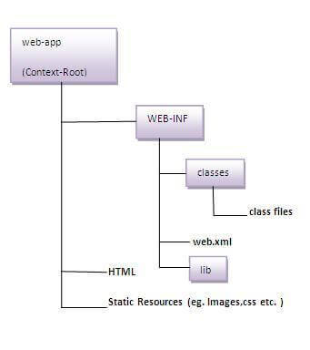

**JSP** technology is used to create web application just like Servlet technology. It can be thought of as an extension to Servlet because it provides more functionality than servlet such as expression language, JSTL, etc.

A JSP page consists of HTML tags and JSP tags. The JSP pages are easier to maintain than Servlet because we can separate designing and development. It provides some additional features such as Expression Language, Custom Tags, etc.

### **The Lifecycle of a JSP Page**

The JSP pages follow these phases:

* Translation of JSP Page
* Compilation of JSP Page
* Classloading (the classloader loads class file)
* Instantiation (Object of the Generated Servlet is created).
* Initialization ( the container invokes jspInit() method).
* Request processing ( the container invokes _jspService() method).
* Destroy ( the container invokes jspDestroy() method).

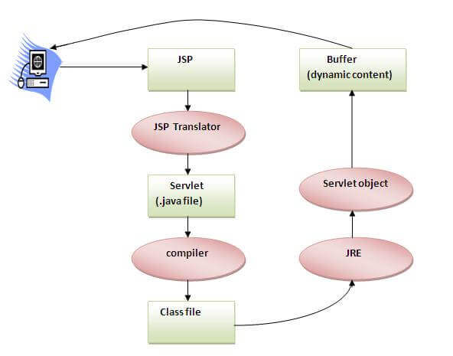

### **Creating a simple JSP Page**

To create the first JSP page, write some HTML code as given below, and save it by .jsp extension. We have saved this file as index.jsp. Put it in a folder and paste the folder in the web-apps directory in apache tomcat to run the JSP page.

**index.jsp**

Let's see the simple example of JSP where we are using the scriptlet tag to put Java code in the JSP page. We will learn scriptlet tag later.

1. <html>
2. <body>
3. <% out.print(2*5); %>
4. </body>
5. </html>

**Code**:

1. ***Web.xml Code****:*

<?xml version="1.0" encoding="UTF-8"?>

<web-app version="3.1" xmlns="http://xmlns.jcp.org/xml/ns/javaee" xmlns:xsi="http://www.w3.org/2001/XMLSchema-instance" xsi:schemaLocation="http://xmlns.jcp.org/xml/ns/javaee http://xmlns.jcp.org/xml/ns/javaee/web-app_3_1.xsd">

<servlet>

<servlet-name>NewServlet</servlet-name>

<servlet-class>NewServlet</servlet-class>

</servlet>

<servlet-mapping>

<servlet-name>NewServlet</servlet-name>

<url-pattern>/NewServlet</url-pattern>

</servlet-mapping>

<session-config>

<session-timeout>

30

</session-timeout>

</session-config>

</web-app>

1. **Index.html Code:**
2. Top of Form
3. Bottom of Form

Top of Form

Top of Form

Bottom of Form

<html>

<head>

<title>TODO supply a title</title>

<meta charset="UTF-8">

<meta name="viewport" content="width=device-width, initial-scale=1.0">

</head>

<body>

<form action="Jsp.jsp" method="get">

First Name:<input type="text" name="n1"> <br> <br>

Last Name:<input type="text" name="n2"> <br> <br>

Email-Id:<input type="email" name="n3"> <br> <br>

Phone-Number:<input type="tel" name="n4"> <br> <br>

<input type="submit" name="btn1" value="Submit">

</form>

</body>

</html>

* 1. **Jsp.jsp:**

<%--

Document : Jsp

Created on : Apr 13, 2021, 12:05:16 PM

Author : user new

--%>

<%@page contentType="text/html" pageEncoding="UTF-8"%>

<!DOCTYPE html>

<html>

<head>

<meta http-equiv="Content-Type" content="text/html; charset=UTF-8">

<title>JSP Page</title>

</head>

<body bgcolor='blue'>

<%

String name,lastname,email,phono;

name = request.getParameter("n1");

lastname = request.getParameter("n2");

email = request.getParameter("n3");

phono = request.getParameter("n4");

out.println("<html><h1>"+"First Name:<br>"+name+"<br>"+"Last Name:<br>"+lastname+"<br>"+"email:<br>"+email+"<br>"+"Phone-Number:<br>"+phono+"</h1></html>");

%>

</body>

</html>

**Output:**

Top of Form

1. Form

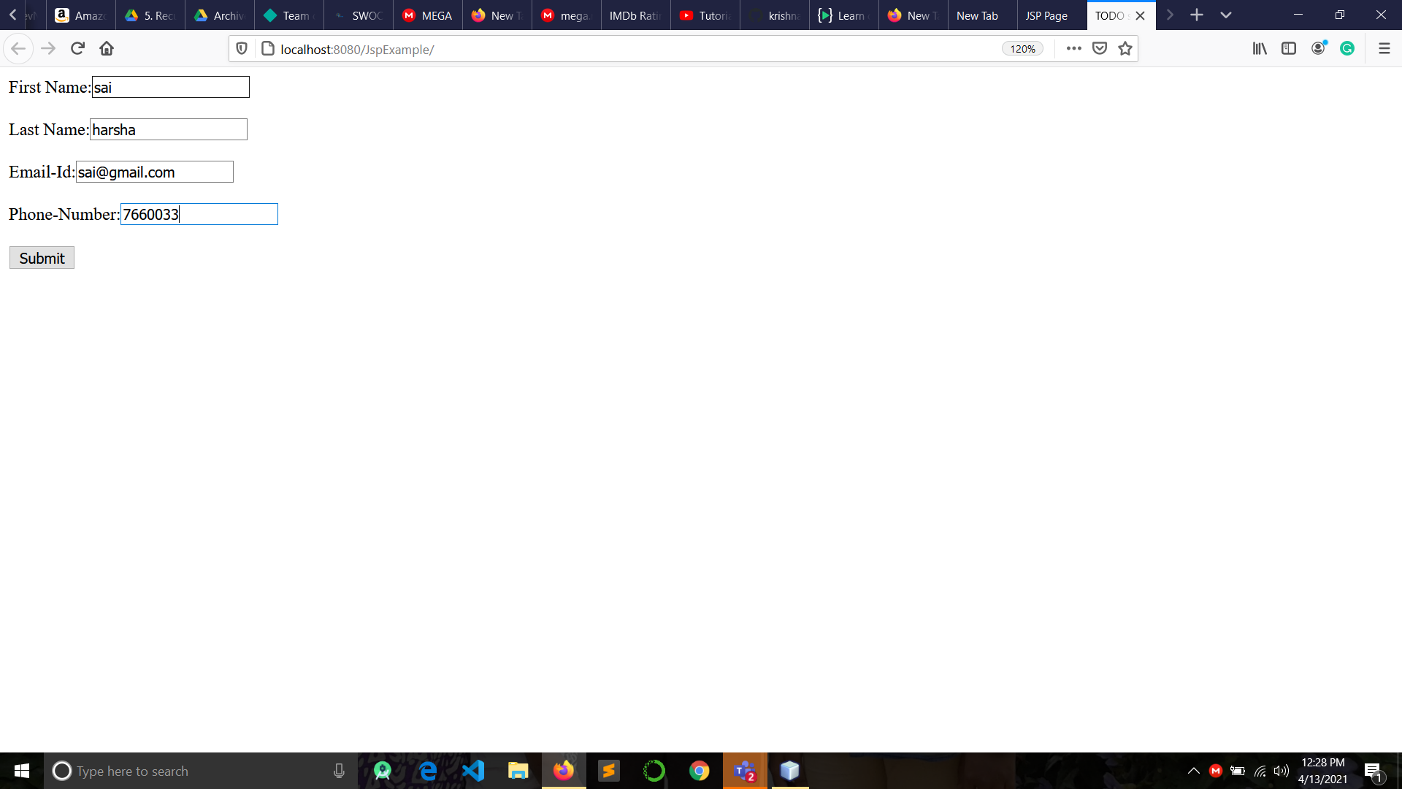

1. After Submitting the form

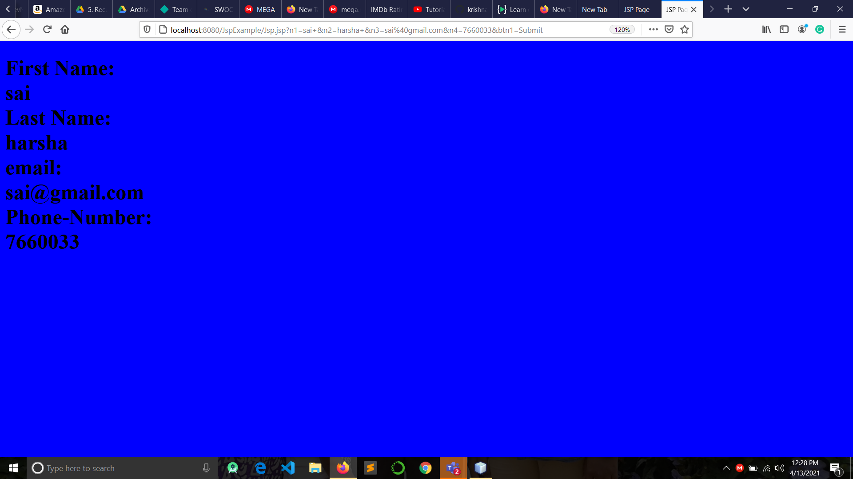

**Conclusion:** Simple JSP is created successfully.